business process specification

# Information about the document

|  |  |
| --- | --- |
| Name of business process | Name defining the essence of the process  Order processing |
| Process category | The category or type of process according to the classification adopted by the organisation.  Key process |
| Process level | Process level in the hierarchy  Example of a 4-level hierarchy:  Level 1 Business process map  Level 2 Business process - Business use case / activity level  Level 3 Business process - task level |
| Process group | Name of the group to which the process belongs  Customer service.Procurement |
| Author |  |
| Version | 1.0 |
| Status | E.g. reported, in analysis, accepted for implementation |
| Date of last change |  |
| Compliance with strategic objectives | Identifier of the business objective whose realisation is supported by this business proceess  BG 01  BG 05 |

1. Business process goal

Definition of the purpose of the process explaining the value provided by the process

The aim of the process is to fulfil the customer's order and prepare it for shippment.

1. Entry criteria

Definition of the input criteria for the process, i.e. the conditions that must be met before the process can start.

Order placed by [customer] in the computer system

Order placed by [customer] in a stationary shop and registered by [customer service agent] in the computer system

1. Inputs

Precise definition of input information for the process. This can be documents, Change in object status, Electronic information, Signal received from another process.

[Order].

* Goods identification number
* Product specifications
* Number of units
* Date of order
* Information on the method of payment: in advance or on delivery.
* Information on the payment document:, invoice or receipt.

Details of the customer placing the [order]

* [Individual customer]:
  + Name
  + Address
  + Contact telephone
* [Corporate customer]
  + Company name
  + Address
  + NIP
  + Contact details: name, telephone number

1. Business process model

A diagram representing a business process model, depending on the level of detail, can present general activities or detailed tasks. The diagram should explain how the different activities relate to each other, the order in which the activities are carried out and who is responsible for carrying out each activity.

The diagram should include the positive flow as well as the exception and alternative flows. Depending on the level of detail of the model, information about the inputs and outputs of each activity can be included on the model.

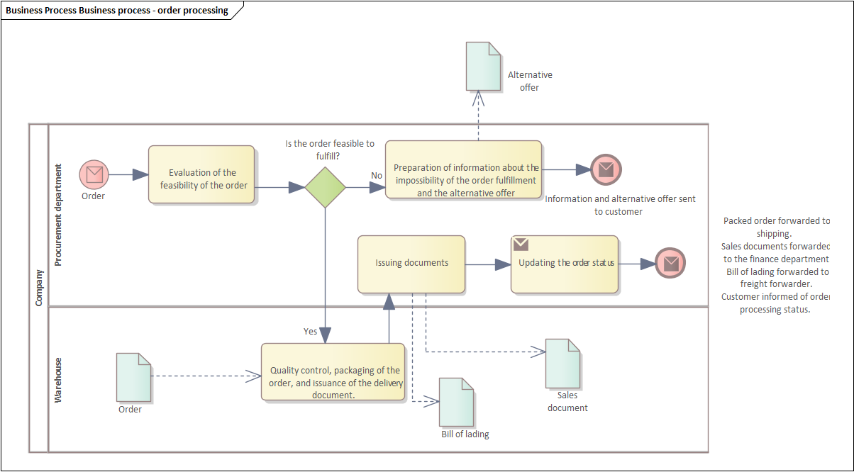

1. Descriptions of activities

A description of the individual activities with initial conditions, identification of the roles involved and the outcome of the activity.

* 1. Activity 1

A description of the activity in a form that enables the recipient to understand the nature of the activity. Do not use sentence equivalents. The activity description should indicate the purpose of the activity and its results.

Assessing the feasibility of the order.

The purpose of this activity is to check whether it is possible to fulfil the order placed by the [customer].

* + 1. Initial conditions

A description of the conditions that must be true for an activity to start. For example, access to a particular piece of information.

The [order processing clerk] has access to the current [order processing plan].

The [order processing clerk] has access to the current [stock information].

* + 1. Metrics

Definition of the metrology associated with a specific activity. For example, average resource consumption, lead time.

Maximum lead time for activities:

* 4 h order [individual customer].
* 8 h order [corporate customer].
  + 1. Roles and responsibilities

An indication of the roles involved in carrying out the activity and the type of involvement. Specific roles may perform the activity, others may provide the input necessary to carry out the activity. RASCI can be used to identify responsibilities.

Head of procurement services A

Order processing clerk R

Production worker S

Warehouse employee S

Customer service assistant I

* + 1. Result

The results of performing an activity should be defined in a precise and measurable way. Each activity should generate a specific result.

Assessment of feasibility of [order] - order marked as [accepted for processing] or [on hold].

1. 2 Exceptions /alternative paths

Description of alternative paths and exception flows. For each flow, indicate the start and end conditions, i.e. the state at the end of the flow.

* 1. Path description 1

Identification of an alternative flow with an indication of its purpose.

No order possible.

This flow handles the situation where, after analyzing the feasibility of an [order]. The [order processing clerk], based on the available information, assesses that the order is not feasible at the moment and prepares [an alternative offer] for the [customer].

* + 1. Trigger

Identify an exception or alternative flow trigger. What needs to happen for the process flow to move in a particular direction.

The [order processing clerk] decides that [the order] cannot be fulfilled and an [alternative offer] is prepared for the [customer].

* + 1. Initial conditions

A description of the conditions that must be true for the flow to begin....

The information contained in the current [order fulfilment plan] or [stock information] indicates that it is not possible to fulfil [order].

* + 1. Activities

Preparing information about the impossibility of fulfilling the order and preparing an alternative offer for the customer. [order processing clerk] prepares a letter with information about the impossibility of fulfilling [order] and [reason]. The [order processing clerk], based on the information about [order fulfilment plans] and [stock information], prepares an offer including:

1. Proposal for a contract with a different [specification], feasible at present
2. Proposal for a new [contract] completion date
   * 1. Roles and responsibilities

Head of procurement services A

Order processing clerk R

* + 1. Final conditions

End conditions of an alternative or exception flow. For example, an end condition could be the termination of a process or the start of another process, such as exception handling

[Alternative offer] sent to [customer].

Letter stating that [order] cannot be fulfilled sent to [customer].

Fulfilment of[ order] suspended

1. Business rules

Definition of business rules for the whole process or its individual activities.

The maximum order value from [individual customer] is xxx

An order from [corporate customer] must be confirmed with the customer over the phone by [order processing clerk].

1. Outputs

Definition of precise and measurable results of process implementation.

Documents supporting the execution of the contract.

Warehouse release document.

Invoice or receipt - depending on the information on the order.

Bill of landing.

1. Consumers / recipients of the results of the process

Roles, departments or organisations using the results of the process.

Finance department

Forwarder

Customer

1. Exit criteria/conditions

End-conditions for the process - conditions that must be true in order to consider the process completed. End conditions should be consistent with the definition of outcomes.

Packed [order] forwarded to shipping.

[Sales documents] forwarded to the finance department.

[Waybill] forwarded to the freight forwarder.

[Customer] informed of the status of the [order].

1. Related processes

Identification of related business processes.

Registration of sales